**Openfabric AI platform's key features:**

* Openfabric AI is an advanced technology that combines blockchain and Artificial Intelligence (AI).
* It helps to overcome the challenges faced by AI platforms and makes it easier for people to use AI applications.
* It is a groundbreaking technology that improves how AI works, making it more accessible and beneficial for everyone.
* One important aspect of Openfabric AI is its consensus protocol, which allows for multiple decisions to be made in parallel, leading to a faster and more efficient system.
* The Openfabric Community AI Apps – encompassing Artfabric, Memefabric, Soundfabric, and QRfabric – represents a holistic approach to creativity and innovation.
* The $OFN token is the native digital currency of the Openfabric AI network, serving as a vital component in promoting responsible network behavior and facilitating various functionalities.

**Bug Report:**

1. In Openfabric homepage🡪 AI Marketplace🡪Top Rated Apps

Clicking AtoZ does not sort apps in ascending order.

1. Moving to shortlist requires signing in again- As user is already signed in, should not be prompted.

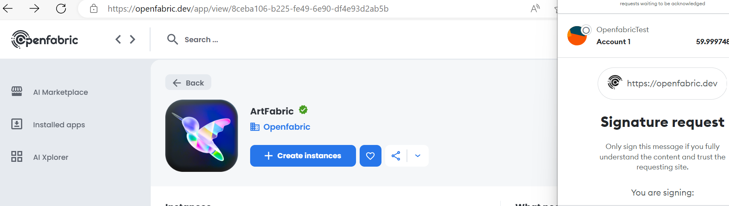

1. When I provide the prompt for my ArtFabric and Run it, Image is not generated with 1st infrastructure provider node-gpu0.

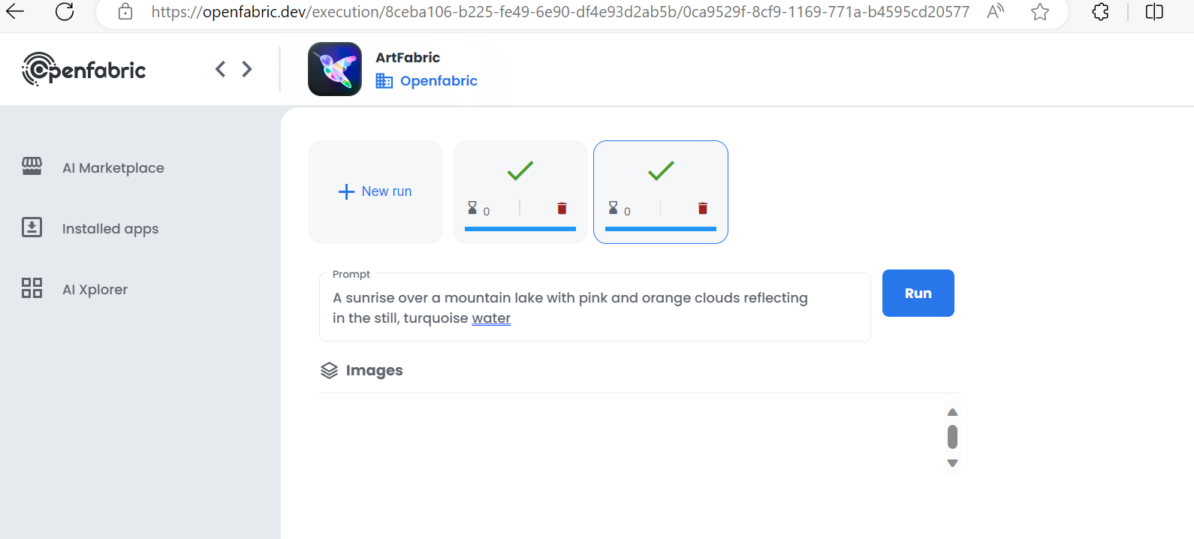

**Steps to reproduce:**

1. Click Marketplace button from left menu
2. Choose ArtFabric app from Top rated apps menu
3. Click Create Instances
4. Choose 1st infrastructure **openfabric-node0-gpu0.** Click Continue
5. Sign in again to proceed
6. Verify payment details and click Confirm.
7. Wait till app is set up and ready to use
8. Enter required art details in prompt box and click Run

**Expected Result:**

Prompt should run successfully with provided details. Images should be displayed accordingly.

**Actual Result:**

No image is displayed when I use this particular infrastructure.

**Problem-solving scenario:**

We have to ensure that if user chooses 1st infrastructure node-gpu0 of ArtFabric, then all necessary installations are setup. This will help user to generate AI images as per the prompt. At the moment images are not generated when node-gpu0 is selected by user.

**Stakeholder communication:**

When user purchases any app, then it is necessary to purchase an infrastructure along with it to make AI app setup easier. AI images will be generated as per the prompt only when proper infrastructure setup is done. But when user purchases ArtFabric app and node-gpu0 infrastructure, then AI image is not generated with whatever AI prompt user is providing.